LAB 3 of DSA230/CIS492 - Cleveland State University
2:00pm-3:15pm of 11/10/2022
Due time: 11:30 pm of 11/12/2022

[100 points in total] Please finish this lab assignment independently. You may use notes, slides or internets for your references. If you have any questions, you can ask the TA for help. If you cannot finish all the tasks, do not worry and just submit whatever you have already written for partial credits. Lab submission late within 24 hours will receive 20% deduction for late submission. Lab submission late more than 24 hours but within 48 hours will receive 40% deduction for late submission. Lab submission late more than 48 hours is not accepted except a significant emergency. Code must be written in Python3 and submitted via Blackboard. Sorry about no email attachment for submission.

Objective
Create a python program that draws special functions (Sin, Cos and multiple Gaussian distributions) using module.
Specification:
- Please define a module named drawing to contain different drawing functions:
gauss(x, mean, std): given
DrawSin(x, save_name)
DrawCos(x, save_name)
DrawGMM(x, A, save_name)
where x is a numpy array, A is a dictionary storing many Gaussian distributions where each key-value pair is the mean-standard deviation pair for one Gaussian distribution, and save_name is a string for the figure name to be saved.
For example:
import numpy as np
x = np.linspace(0, 30, 100)
A={10:2, 15:3, 11:1}
save_name='my_test1.png'
Note that: you do not have prior knowledge about the number of Gaussian distributions in A. Hard coding will receive 0 points. You need to write a loop to access each Gaussian distribution in A.
- Please use the given test script Lab3.py to call and test the drawing functions in the module of drawing.
Requirements:
- You just need to submit your modified drawing.py for grading. Figures are just for your debugging, which are not required for grading.
- For the generated figures, title is your First Name + Last Name, x-axis is labeled as ‘x’, and y-axis is labeled as ‘y’.
- Please do not modify the function names and arguments (input) for drawing.py.

Example for Generated Figures:
Sin:
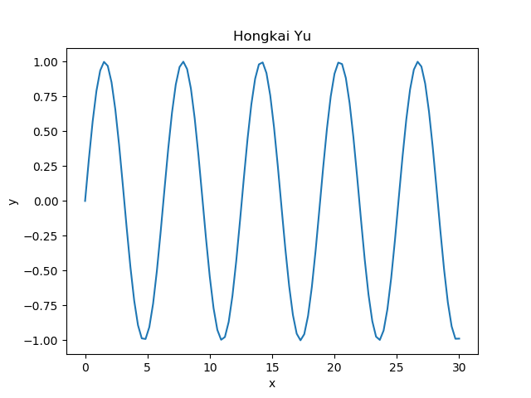
Cos:
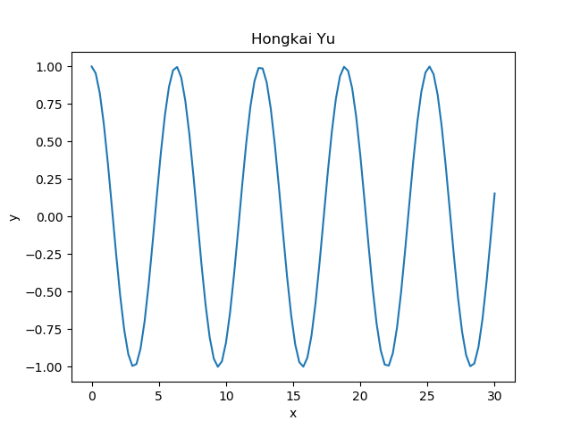

Drawing when A contains 3 Gaussian distributions:
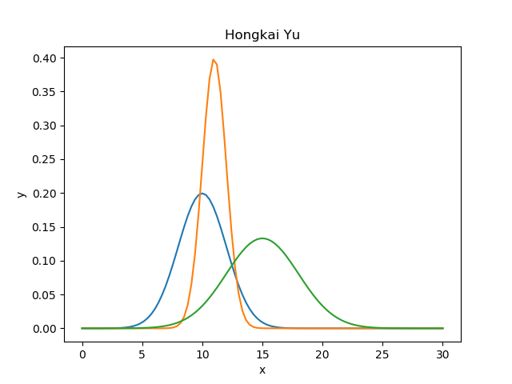
Drawing when A contains 2 Gaussian distributions:
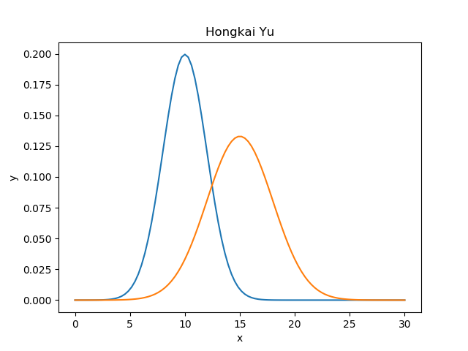

Drawing when A contains 1 Gaussian distribution:
